**Self-Training: A Semi-Supervised Learning Approach for Label-Efficient Classification**

**Theory Section:**

**What is Self-Training?**

**Self-training** is one of the simplest and most intuitive methods in **semi-supervised learning** (SSL), where a model is trained using a small set of labeled data and a larger set of unlabeled data. The idea is to let a confident classifier **teach itself** by iteratively labeling the unlabeled data and retraining on its own predictions (Nigam et al., 2000).

In supervised learning, every training sample must have a corresponding label. However, in many real-world settings (e.g., medical imaging, sentiment analysis, fraud detection), acquiring labeled data is expensive or requires domain experts. Self-training aims to **minimize labeling costs** by intelligently leveraging unlabeled data.

**How It Works (Step-by-Step)**

1. **Train Initial Model**  
   A base classifier (e.g., logistic regression or decision tree) is trained on the small, labeled dataset.
2. **Predict on Unlabeled Data**  
   The model makes predictions on the unlabeled pool and attaches confidence scores.
3. **Select Confident Predictions**  
   Unlabeled examples with the **highest prediction confidence** are pseudo-labeled and added to the labeled dataset.
4. **Retrain the Model**  
   The model is retrained on the enlarged labeled dataset. This process is repeated until a stopping criterion is met (e.g., max iterations or label budget).

This is often referred to as **wrapper-style semi-supervised learning** because the base classifier is wrapped in a self-training meta-strategy (Yarowsky, 1995).

**📐 Mathematical Foundation**

**Advantages**

* **Simplicity**: Easy to implement using any base classifier (e.g., logistic regression, SVM).
* **Model-agnostic**: Can be applied to any supervised learner that outputs probabilities.
* **Data-efficient**: Uses abundant unlabeled data to improve learning with minimal labeling cost.

**Limitations**

* **Error Amplification**: If the model makes incorrect predictions with high confidence, these errors are propagated and reinforced.
* **Bias Risk**: The model’s initial bias can skew the selection of pseudo-labeled data.
* **Imbalance Sensitivity**: May favor majority classes if not properly tuned.

To mitigate these, modern variations use **confidence thresholds**, **ensemble methods**, or **agreement from multiple views** (i.e., co-training).

**Real-World Applications**

* **Healthcare**: Labeling X-rays or MRI scans requires doctors; self-training can expand the training set with high-confidence unlabeled images.
* **Text Classification**: Spam detection, sentiment analysis, or news categorization often start with a few labeled examples.
* **Finance**: Fraud detection models benefit from leveraging the massive volume of unlabeled transaction logs.

**Comparison with Other SSL Techniques**

|  |  |  |  |
| --- | --- | --- | --- |
| **Method** | **Requires Probabilities** | **Uses Multiple Views** | **Example** |
| Self-Training | ✅ Yes | ❌ No | Logistic Regression with Confidence |
| Co-Training | ✅ Yes | ✅ Yes | Separate classifiers on different features |
| Label Propagation | ❌ No | ❌ No | Graph-based methods |

Self-training is often used as a **baseline** or **entry-level SSL strategy** because of its simplicity and general applicability (Zhu & Goldberg, 2009).

**When to Use Self-Training?**

* You have a **small, labeled dataset** and a **large pool of unlabeled data**
* You want a **quick, interpretable, and effective SSL method**
* You are working in **resource-constrained environments** or early stages of ML prototyping

**Self-Training with Semi-Supervised Learning on Wine Quality Dataset**

This tutorial demonstrates **Self-Training**, a popular semi-supervised learning approach where a model iteratively teaches itself using its own high-confidence predictions. We'll use the **Wine Quality** dataset, simulate a scenario where most labels are missing, and train a self-learning classifier using both labeled and pseudo-labeled data.

**Coding Section:**

**Exploratory Data Analysis (EDA)**

We begin by loading and inspecting the dataset. The Wine Quality dataset consists of physicochemical properties (e.g., acidity, pH, alcohol) and a target label quality, which ranges from 3 to 8.

**Step 1: View dataset info and missing values**

print("Shape:", df.shape)

print("\nMissing Values:\n", df.isnull().sum())

print("\nQuality Distribution:\n", df['quality'].value_counts().sort_index())

This helps us verify there are no missing values and understand the distribution of quality scores. Most wines are rated 5 or 6.

**Step 2: Plot quality score distribution**

Figure Bar chart showing imbalanced wine quality classes

**Step 3: Plot feature correlation heatmap**

Figure Heatmap indicating positive/negative correlation between variables like alcohol and quality

**Preprocessing and Label Setup**

Since quality is a multiclass variable, we'll simplify it into binary classification:

* **Good wine (label = 1)**: quality >= 7
* **Not-good wine (label = 0)**: quality < 7

df['label'] = (df['quality'] >= 7).astype(int)

df = df.drop(columns='quality')

X = df.drop(columns='label')

y = df['label']

This step prepares the features (X) and binary target labels (y).

**Simulating Semi-Supervised Learning**

We hide 80% of the labels to simulate a realistic semi-supervised learning problem:

This gives us a mix of labeled and unlabeled samples — ideal for self-training.

**Self-Training Classifier Setup**

**Step 1: Feature Standardization**

Standardizing features ensures the logistic regression model is well-behaved.

**Step 2: Train Self-Training Classifier**

The model is trained on labeled data and gradually incorporates pseudo-labeled samples where prediction confidence ≥ 0.8.

**Model Evaluation**

**Step 1: Classification Metrics**

y_pred = self_training_model.predict(X_scaled)

y_proba = self_training_model.predict_proba(X_scaled)[:, 1]

print(classification_report(y, y_pred))

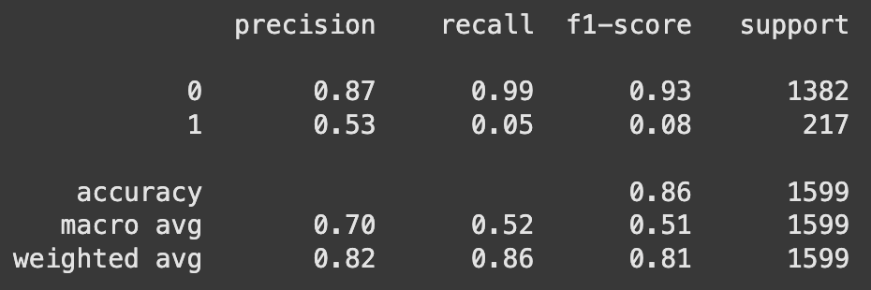

Figure Precision, recall, F1-score for each class

**Step 2: Confusion Matrix**

Figure Heatmap showing true positives, false positives, etc.

**Step 3: ROC Curve**

Figure ROC curve visualizing trade-off between TPR and FPR

**Conclusion**

This tutorial demonstrated the effectiveness of self-training as a semi-supervised learning strategy. Using the Wine Quality dataset, we explored how a base classifier like logistic regression can be enhanced by iteratively labeling and learning from its own confident predictions. This is particularly useful when labeled data is scarce, and unlabeled data is abundant.

Key takeaways:

* Self-training can significantly improve model generalization in label-scarce environments.
* It is model-agnostic and easy to implement using standard libraries like scikit-learn.
* It is important to control for confidence thresholds and validate performance to prevent error amplification.

Overall, self-training offers a valuable balance of simplicity and performance, especially in real-world domains like healthcare, finance, and text classification where labels are expensive to obtain.

**GitHub Repository Setup**

All files for this tutorial are hosted in a GitHub repository to ensure full reproducibility and accessibility.

**Repository:** <https://github.com/yourusername/self-training-winequality>

**📂 Included Files:**

* SelfTraining_WineQuality_Tutorial.ipynb: Full notebook with code and comments
* winequality-red.csv: Input dataset
* README.md: Project overview and setup instructions
* requirements.txt: List of dependencies
* LICENSE: MIT license for open-source sharing

**Accessibility Features**

This tutorial has been designed with inclusivity and accessibility in mind:

* **Colorblind-friendly plots** (Set2, coolwarm, Blues) to support users with color vision deficiency.
* **Markdown structure** using semantic headings for screen readers.
* **Alt-text captions** for each visual for users relying on assistive technology.
* **Clear, concise explanations** for each code cell and output, supporting multiple learning styles.

These steps help ensure the content is understandable and usable by learners of all abilities.

**References**

Nigam, K., McCallum, A., Thrun, S., & Mitchell, T. (2000). *Text classification from labeled and unlabeled documents using EM*. Machine Learning, 39(2–3), 103–134. <https://doi.org/10.1023/A:1007692713085>

Yarowsky, D. (1995). *Unsupervised word sense disambiguation rivaling supervised methods*. In Proceedings of the 33rd Annual Meeting on ACL. <https://doi.org/10.3115/981658.981684>

Zhu, X., & Goldberg, A. B. (2009). *Introduction to semi-supervised learning*. Synthesis Lectures on Artificial Intelligence and Machine Learning, 3(1), 1–130. <https://doi.org/10.2200/S00196ED1V01Y200906AIM006>

UCI Machine Learning Repository. (n.d.). *Wine Quality Dataset*. <https://archive.ics.uci.edu/ml/datasets/wine+quality>